Fun with Tableau_Advanced

Rao Katie Xu

Environment: Win10 64 bit (Parallel Desktop on Mac OSX Yosemite 10.10.5 )

Tableau: <http://www.tableau.com/products/desktop/download>

*Project 1:*

Datasets: <https://www.superdatascience.com/tableau/>

Download: AmazingMartEU2.xlsx

Aim: Find the profit margin of each city.

From the table, we can see the same Order ID with different product names, because the customer might bug several things in one order.

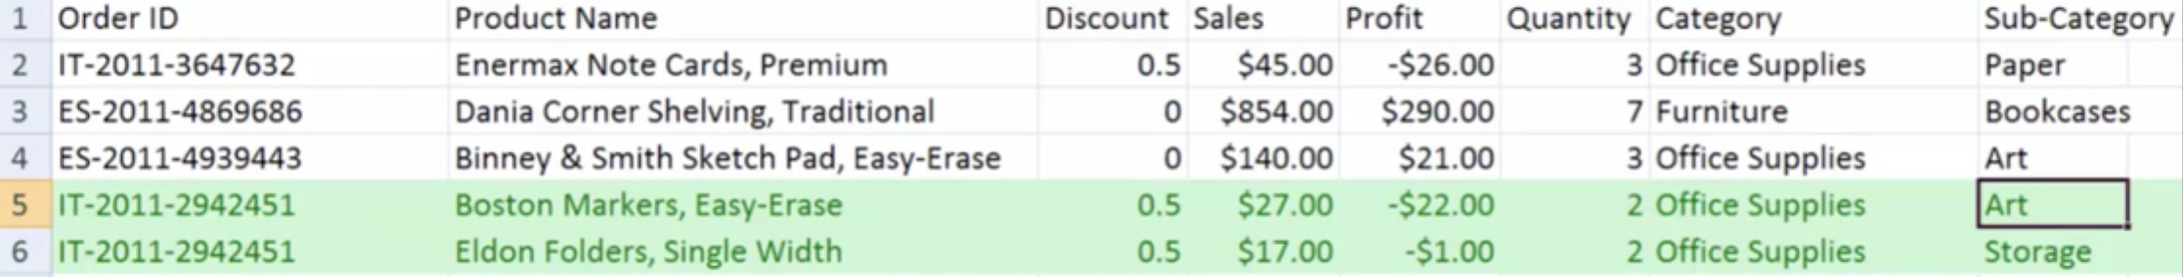

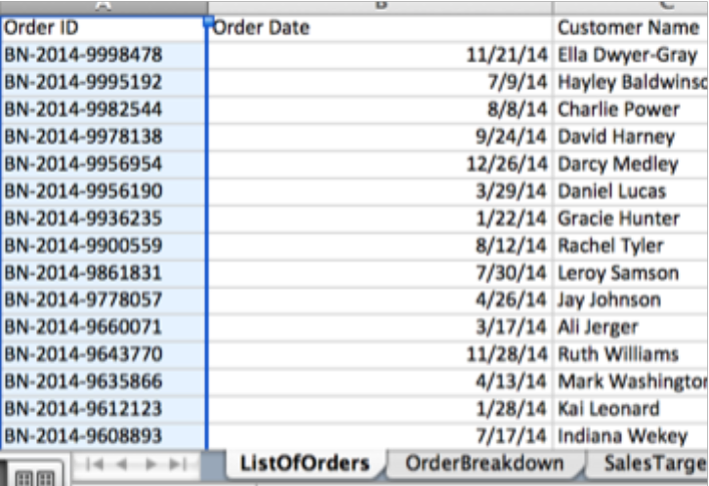 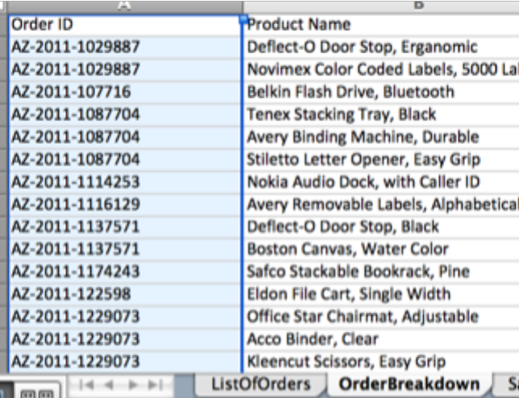

We notice ListOfOrders has unique Order ID and OrderBreakdown has duplicate Order ID, so we want to joint two tables. We drag ListOfOrders and OrderBreakdown to the right area and a crossed circle pop up, click the circles, we can see if it is left join or inner join. Also we need to change the title to ListOfOrders + OrderBreakdown.

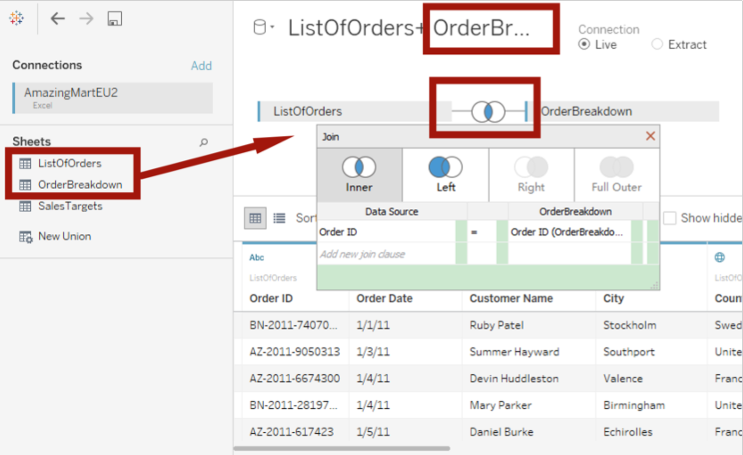

TWB - XML file for your Tableau Workbook, contains all the selections and layout you've made. It does not contain data. These tend to be very small.

TWBX - zipped file that contains the TWB as well as data used by TWB in an extract

Now we should draw map, work with hierarchy and get profit margin.

First, remove hierarchy structure and build our own country-state-city hierarchy. Notice this global sign means geography, Abc means words, calendar sign means date. Right click the City and find Hierarchy -> Create Hierarchy, write the name Geography.

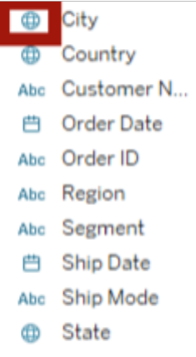 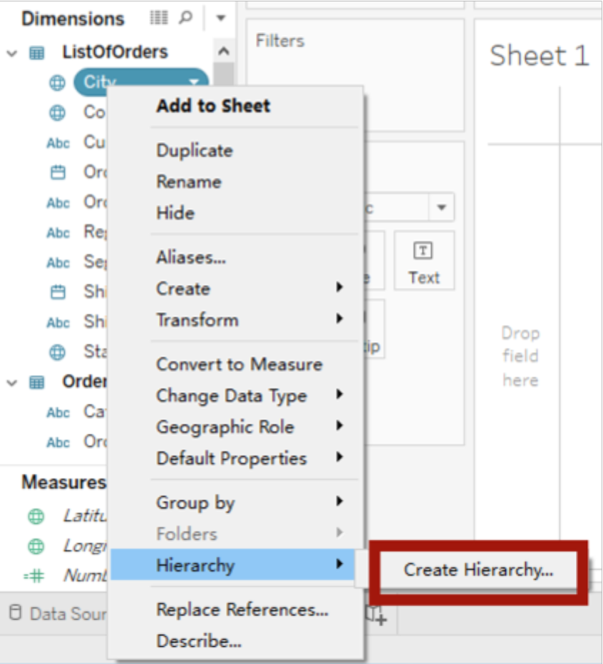

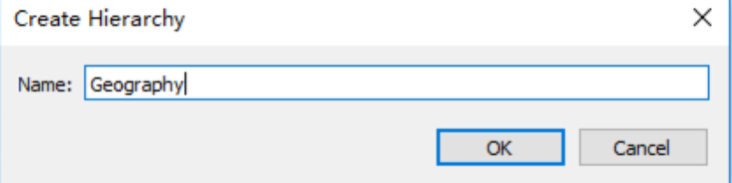

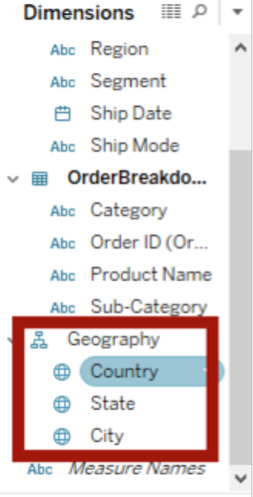

Now we have our own natural hierarchy. Now we can drag the country into our work space. The blue dots are country. And if we click the “+” sign on blue hierarchy structure, we can see state blue dots and city blue dots.

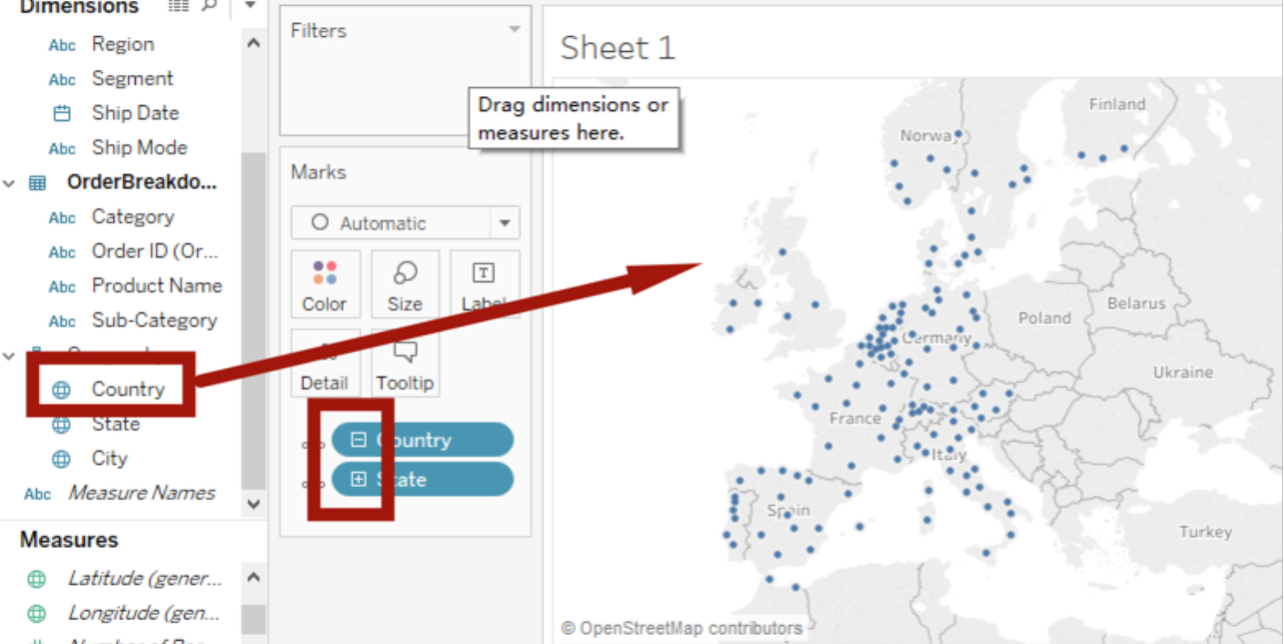

Now the map is ready, we want to see sales on 2012. We drag the OrderDate to the filter, then pop up the Filter Field, we click the # Years.

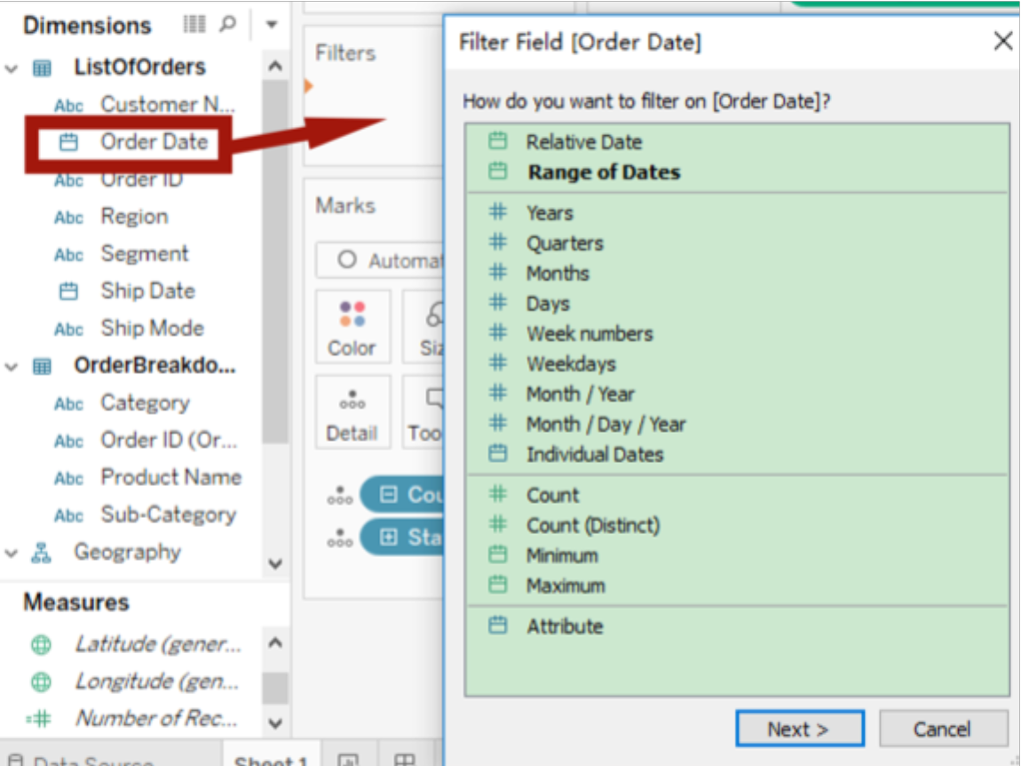 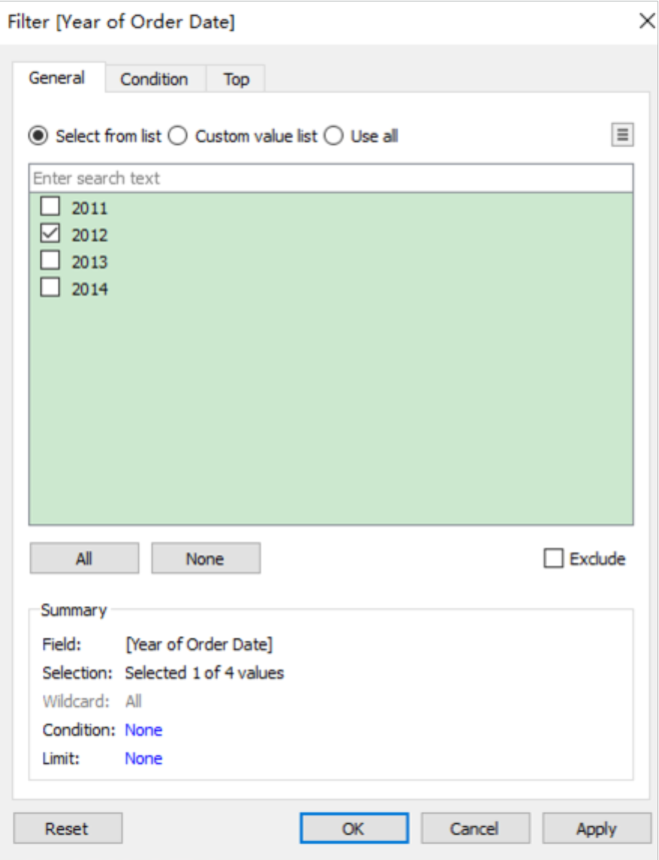

Click the Year in the Filters, and choose Show Filter, it will be more convenient.

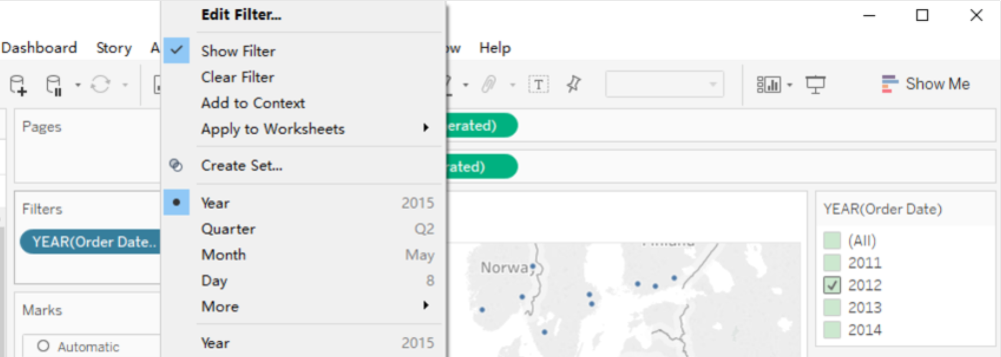

Go to the YEAR(Oder Date) panel, right click, choose Customize-> uncheck Show “All” Value, and choose Single Value(Slider). Now we can play the slide bar to see the changes (dots are moving) by years.

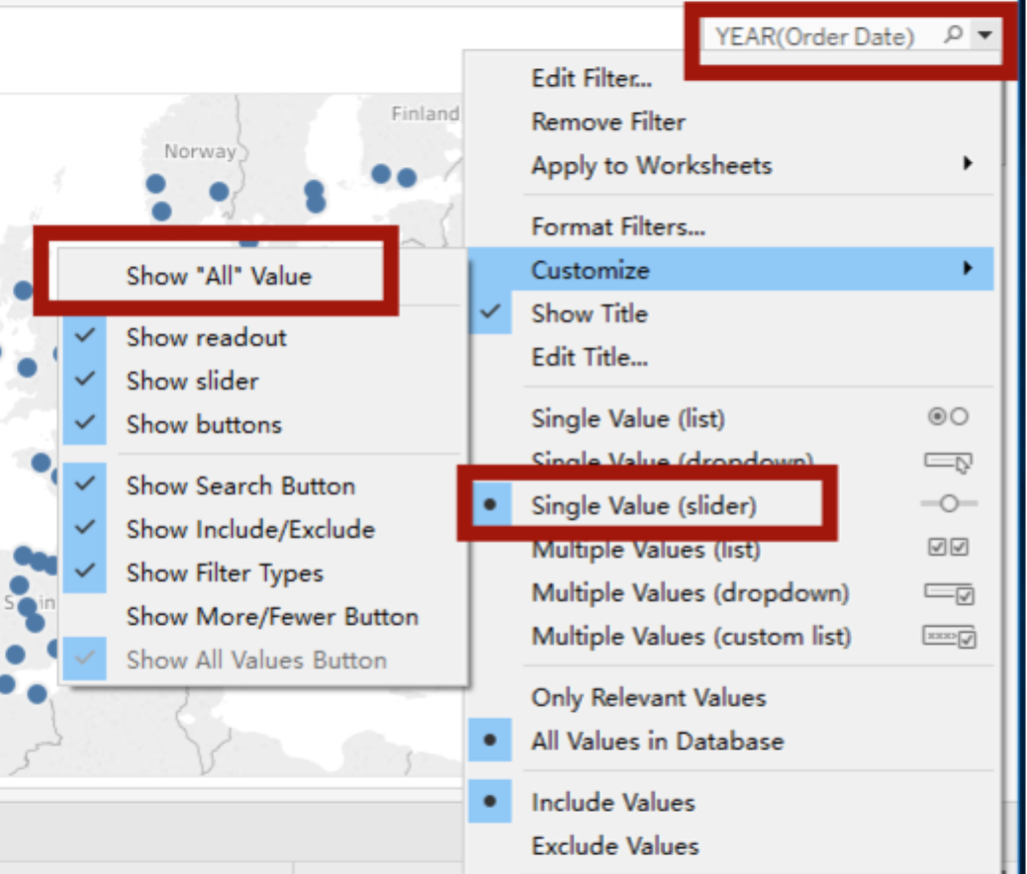

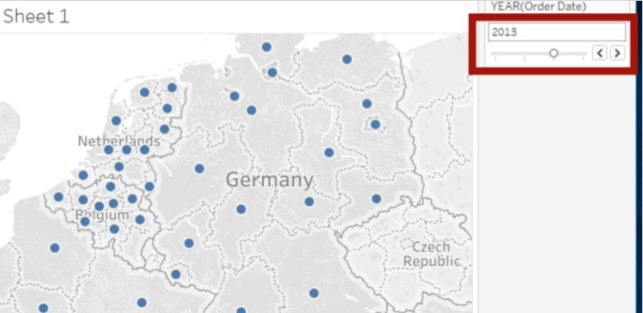

Now we want to see the sales in 2012. Drag Sales into Size. We can see blue circles are sales. Then add Border to black color to make it decent.

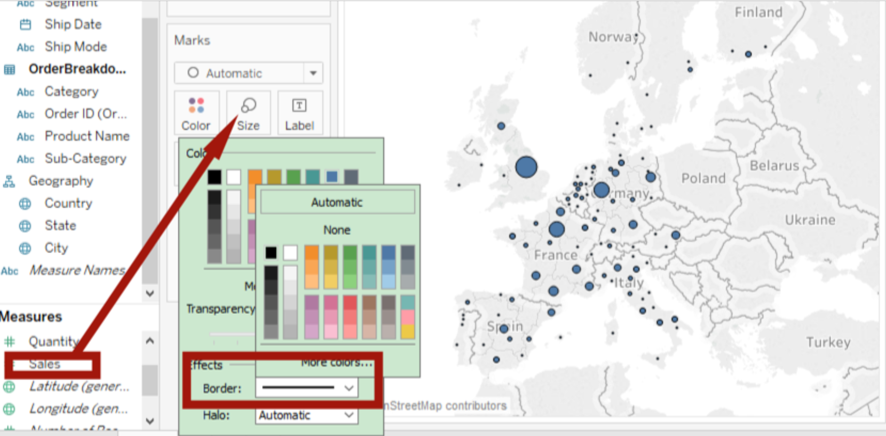

How to find the profit margin? Right click Profit -> Create -> Calculated Field

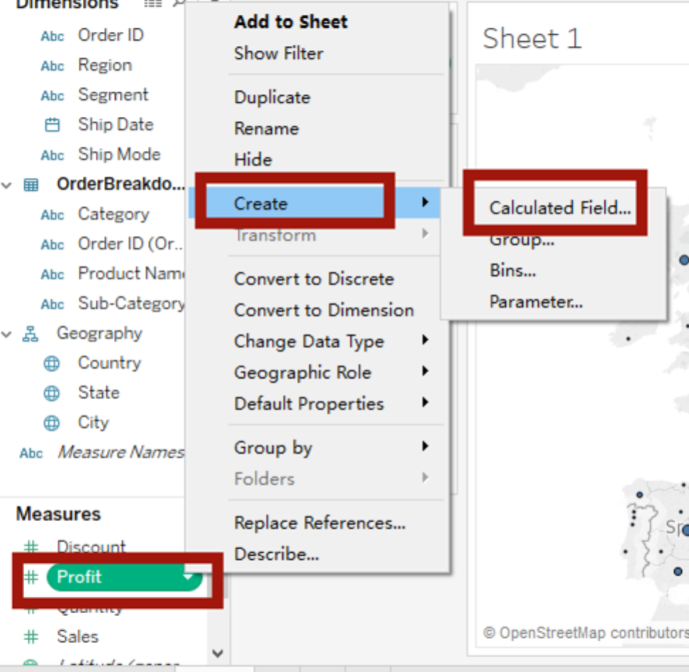

Put name Profit Margin, and the formula SUM([Profit])/SUM([Sales])

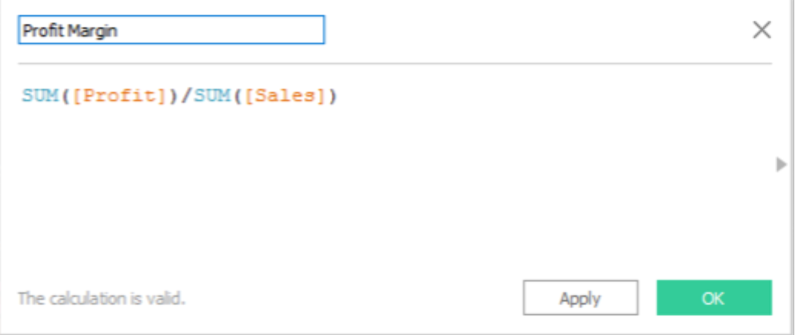

Drag Profit Margin to the Color, now we can see AGG(Profit Margin) which means aggregate Profit Margin.

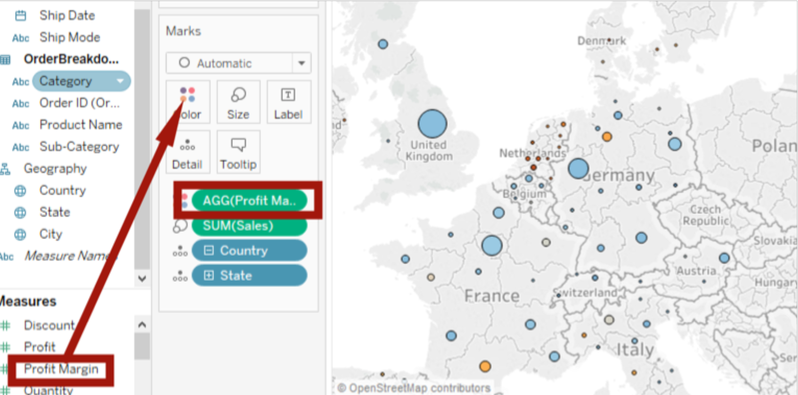

We can change color, just click Color, and click Edit Colors->check Start and End and put -0.5 and 0.5 to limit the color. And all set.

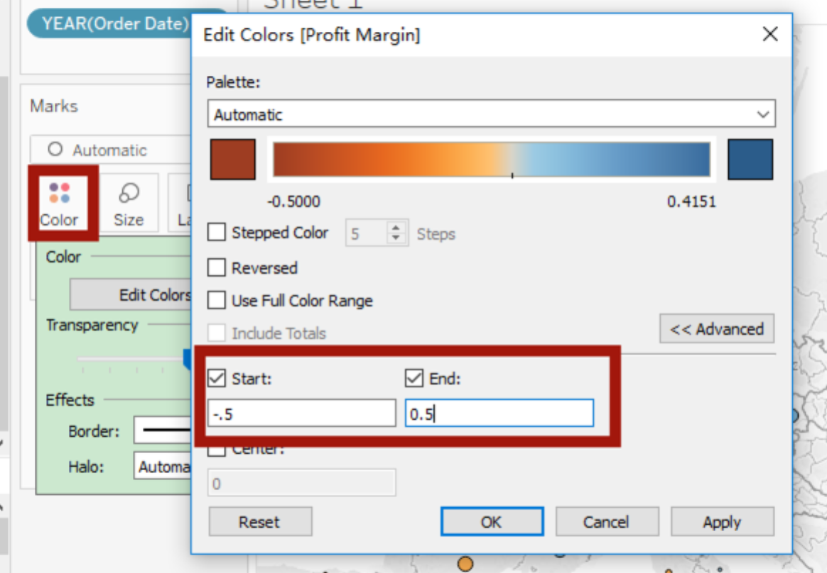

Now we can play with year bar to see the profit margin in 2013 or 2014.

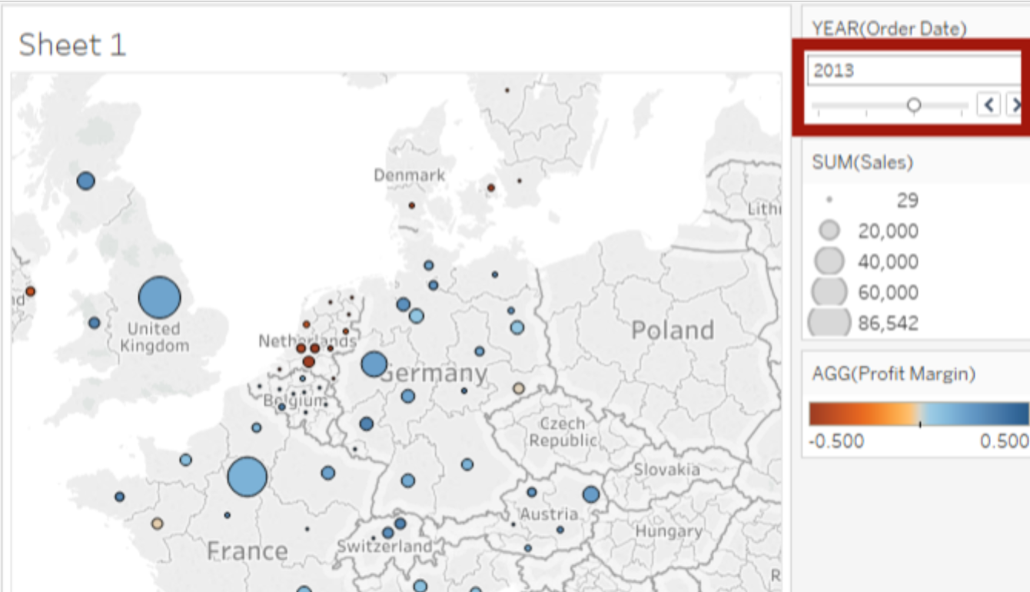

And click arrow to highlight specific area, you can choose radial selection or lasso selection tool to select area to highlight.

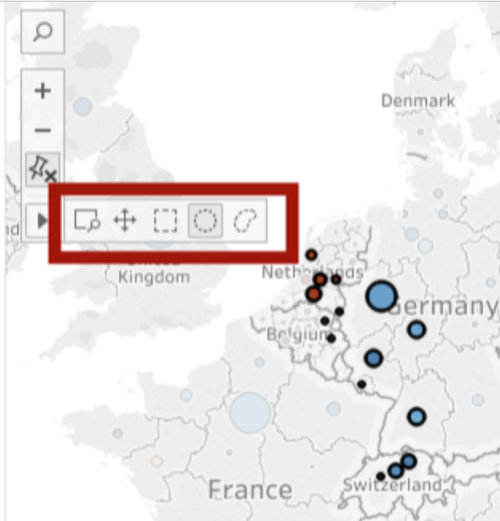 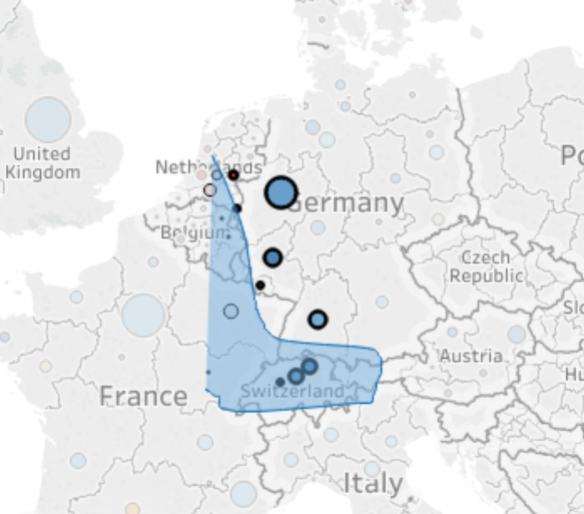

if we want to check city profit margin, we can click City, then more data are shown on map,

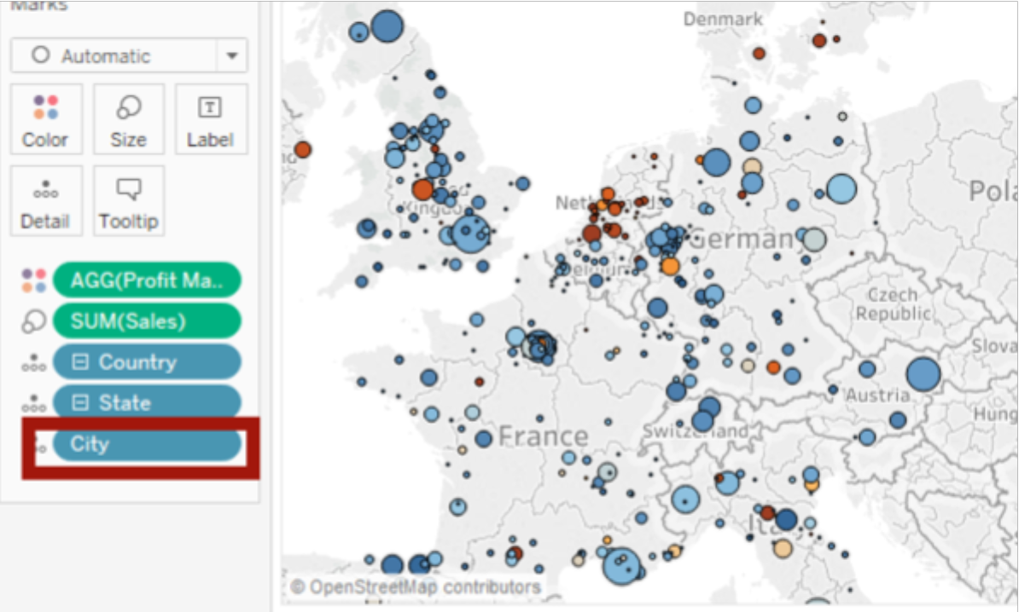

or only Country.

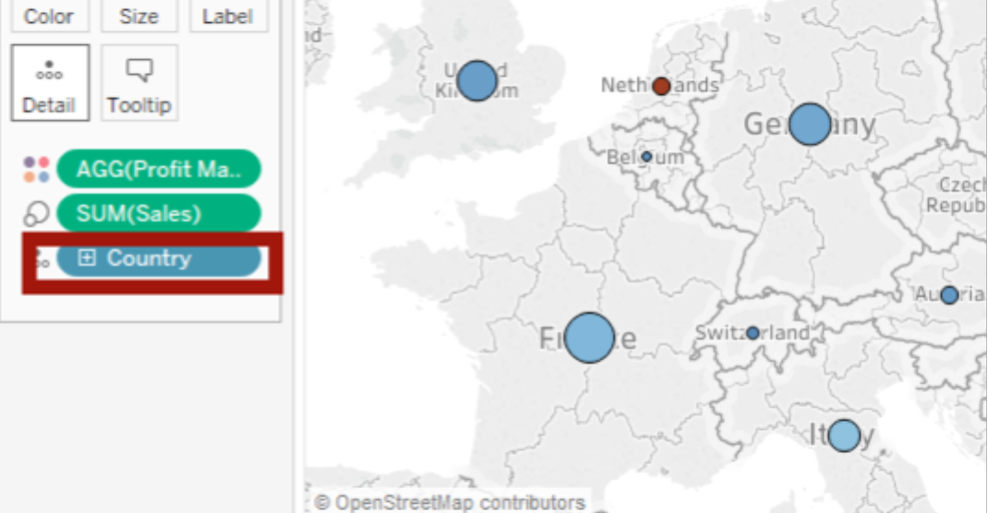

Project 2

Scatter plot, applying filters to multiple worksheets

First we create more worksheets and name it Map of Europe and EOFY

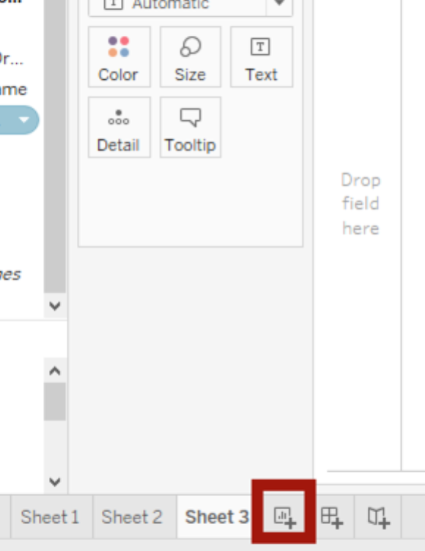 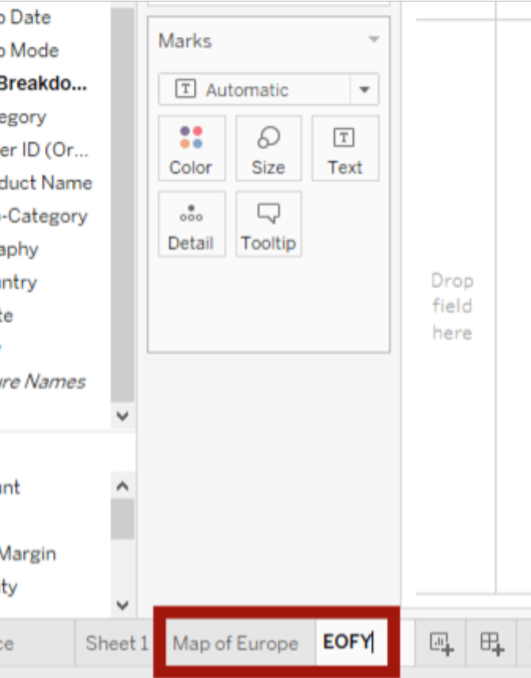

On EOFY worksheet, drag Profit to Columns, Sales to Rows. We find only one dot in the graph, now we need to drag Customer Name to the Detail. Now we can see the scatter plot.

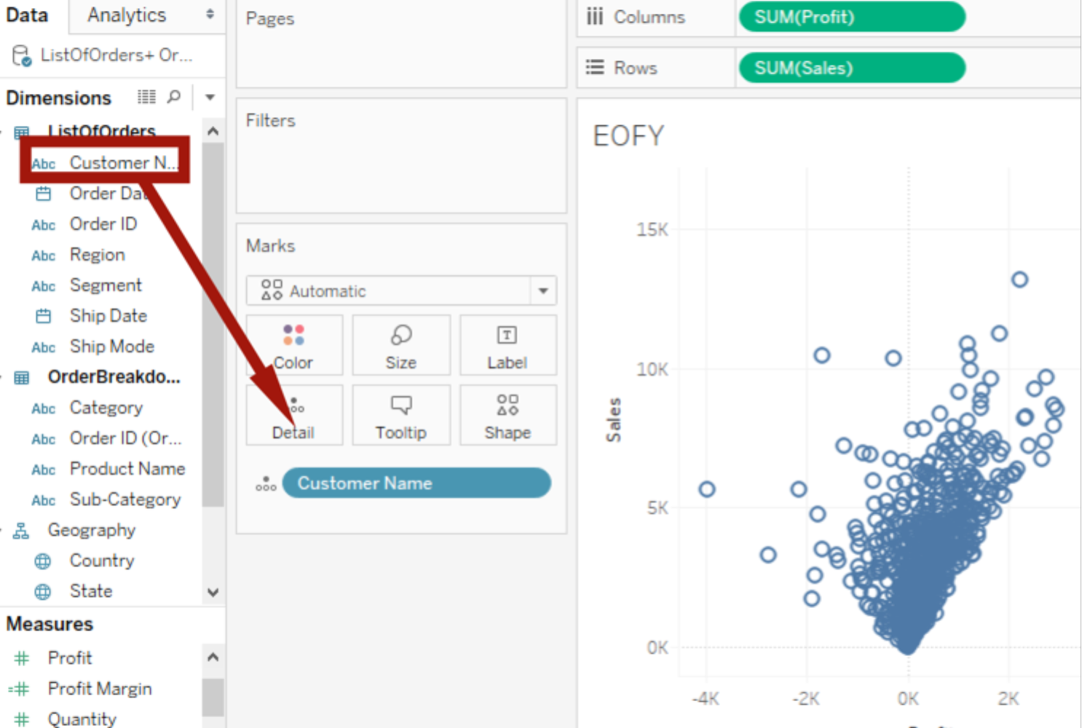

Now go back to Sheet1, right click YEARS in the Filters, choose Apply to Worksheets-> All Using This Date Source, then all worksheets will share the same data source. If we go to EOFY worksheet, it will show the same data source.

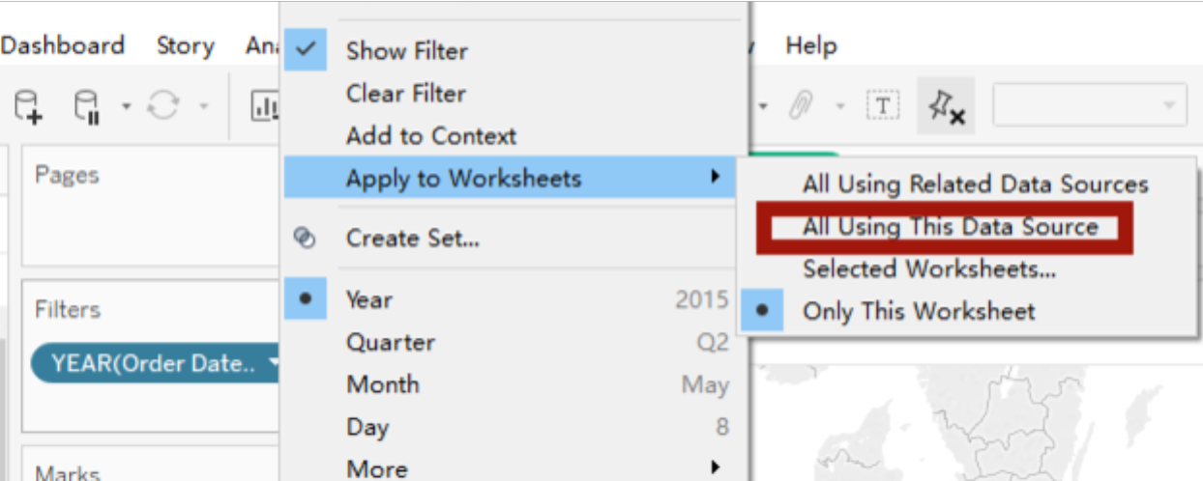

Now we are making the scatter plot prettier. Drag Profit Margin to the color, add some transparency, change size and shape.

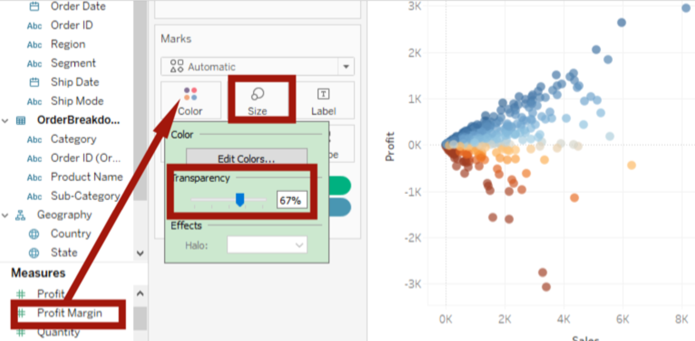

Now we need to put several graphs in the same window.